Date : 19-09-2025

RELIEVING CUM EXPERIENCE LETTER

This is to certify that Mr. Pilli Vishwanth, was working in our Organization OZRIT Ai Solutions PVT LTD as Digital Marketing Executive from 20-01-2025 to 30-08-2025

We hereby certify that his performance was good during the tenure.
His contribution to the organization and its success will always be appreciated.
We wish him all the best in his future endeavors.

For OZRIT Ai Solutions
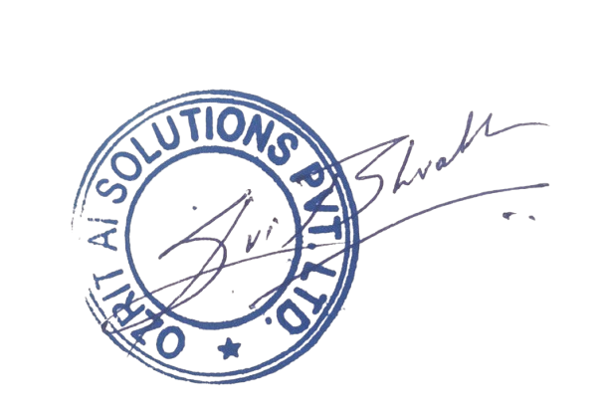

Bharath Gupta
CEO

